# CRUD With File

**Create Migration File**

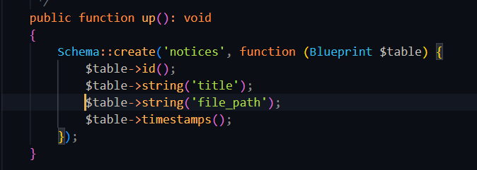

**Create Model**

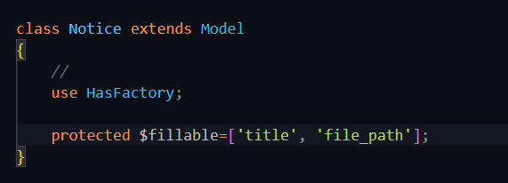

**Create a resource controller**

**Show all**

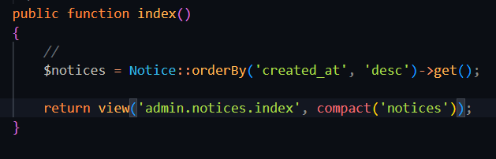



**Create**

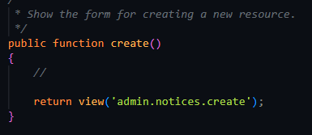





**Store after creation**

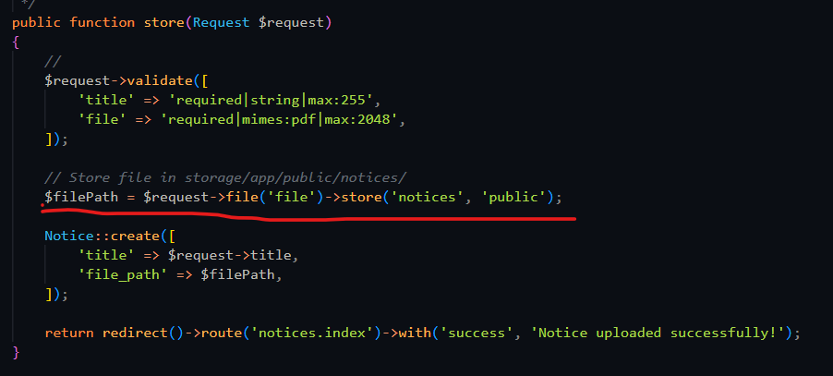



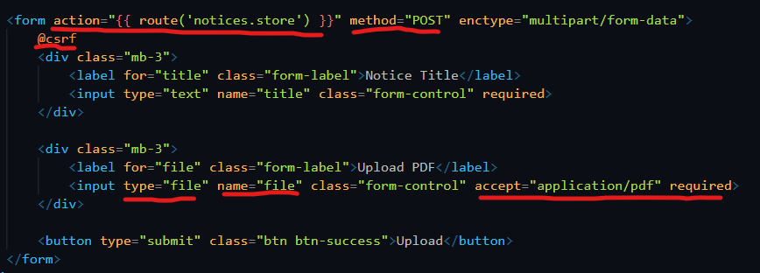

**Edit**

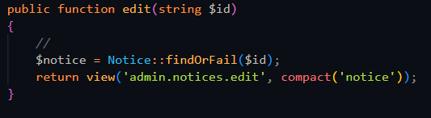





**Update after edit**

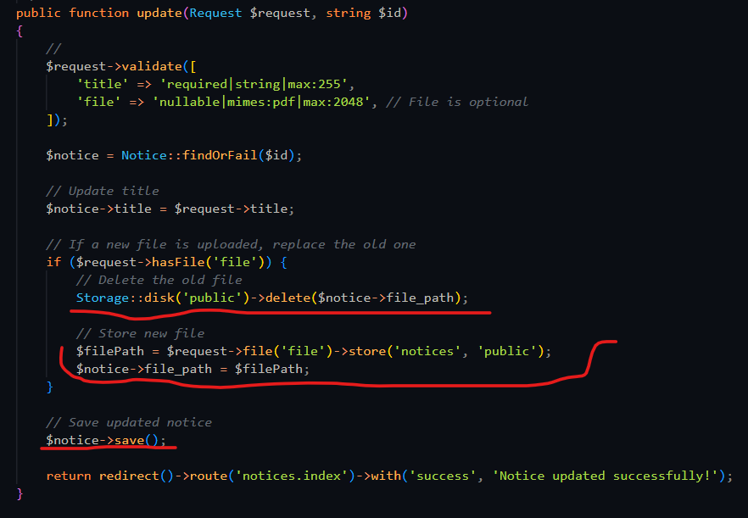



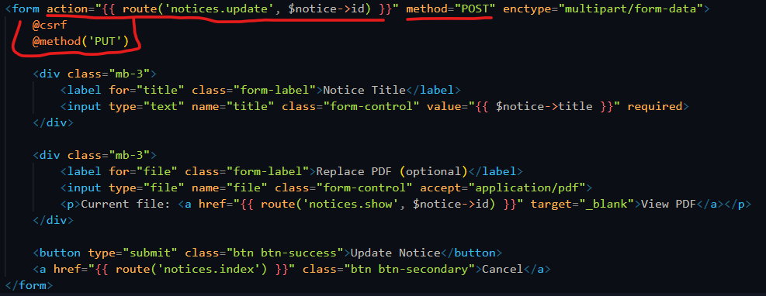

**Show specific file**

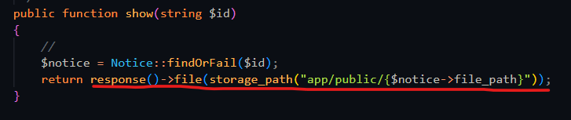





**Delete Specific file**

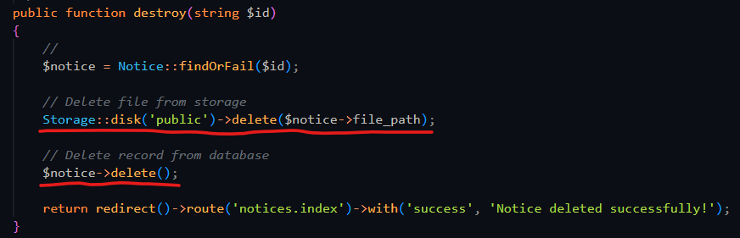



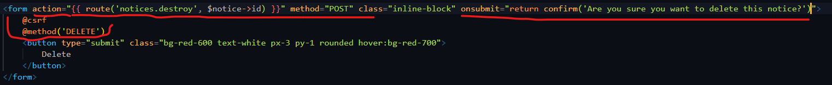

**Setup Storage Link:**

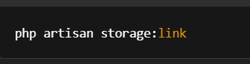

The php artisan storage:link command creates a symbolic link from the public/storage directory to the storage/app/public directory in a Laravel project.

### ****What is a Symbolic Link?****

A symbolic link (or symlink) is like a shortcut or reference to another file or directory in the filesystem. It allows you to access files in one location (e.g., public/storage) that are actually stored elsewhere (e.g., storage/app/public).

### ****Purpose of the**** php artisan storage:link ****Command:****

* **Storage Organization**: Laravel stores files (like uploaded images, PDFs, and other media files) in the storage/app directory. For security reasons, files in the storage directory aren't publicly accessible by default.
* **Making Files Accessible Publicly**: Running php artisan storage:link creates a symbolic link from the public/storage folder to the storage/app/public folder. This makes it possible for web users to access those files through a publicly accessible URL.
  + For example, if you upload a file to storage/app/public/notices/example.pdf, you can access it via http://your-app-url/storage/notices/example.pdf.

### ****How It Helps in Your Project:****

1. **Access Files Publicly**: If you're storing user-uploaded files (like PDFs, images, etc.) in the storage/app/public directory, the symlink allows those files to be served publicly via the public/storage directory. This ensures that users can access the uploaded files via a URL.
2. **URL Generation**: When you use the asset() function in Laravel (like asset('storage/' . $notice->file_path)), Laravel automatically generates the correct URL to access files stored in storage/app/public because of the symbolic link.
3. **Security**: The files are stored outside the public directory, preventing direct access to them via the web unless you explicitly create a symlink. This adds a layer of security while still making the files accessible through URLs.

### ****When to Use:****

* You should run php artisan storage:link when you're dealing with file uploads that need to be publicly accessible (e.g., images, PDFs, documents).
* It's typically done during the initial setup or after setting up file uploads in your Laravel project.

### ****Example of Directory Structure:****

Before running the command:

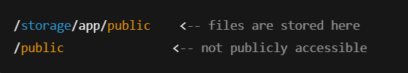

After running php artisan storage:link:

